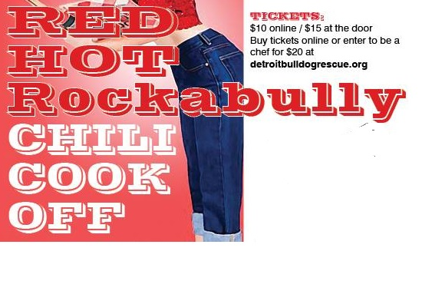
Chili Chef Rules
Thank you for your interest in competing in the 4th Annual Detroit Bulldog Rescue Rockabully Chili Cookoff! Your participation is essential to the success of this event! Below, you will find the rules. Please review them carefully.
Set-up is at 3 pm at the Northville Community Center! However, we’ll provide food and beverages at 2:30 pm so you’ll be fueled up for the big event. Stay tuned for details on our “Thank You” party for Chili Chefs and Volunteers!
All entries must be completed by Sunday, October 30 at 9 pm.
Enter at www.detroitbulldogrescue.org

Official Rules
- Submit your $20 entry fee (includes tables, chairs, tasting cups, spoons, wet wipes, napkins, and CUSTOM DBR apron) by Sunday, October 30!!! You can enter online at www.detroitbulldogrescue.org
- Make at least 2 gallons of your BEST chili
- Provide your recipe, TYPED on an 8x11 page of paper with the title of your entry and your name. Your recipe may be printed and use in future DBR fundraising efforts.
- Bring your own electric crock-pot(s), serving ladle, oven mitts, towels, tablecloth, and extension cord and serve your chili at the proper temperature.
- Prepare your chili in a safe, sanitary, kitchen, taking all necessary precautions to avoid physical or chemical contaminants, since you will be serving your chili to the public, not friends and family in your own home
- You MUST wear some type of hat while serving chili to be in compliance with the Wayne County Health Department guidelines for public food service.
- Arrive at the Northville Community Center promptly at 3 pm on Sunday, November 8 to set up.
- Your chili must be HOT upon arrival, ready to be served. NO ONE will be permitted access to the NCC kitchen.
- Invite your friends and family to buy tickets so you can "stock the pond" and secure votes for YOUR chili in the popular vote.

